15. Harris Corner Detection Using Python and OpenCV
Aim
To read an image in Python and detect corners using the Harris Corner Detection function in OpenCV.
Procedure
- Import OpenCV and NumPy libraries.
- Read the input image.
- Convert the image into grayscale.
- Apply the Harris Corner Detection function.
- Mark the detected corners in red.
- Display the original and corner-detected images.
Program

import cv2
import numpy as np

img = cv2.imread("sample.jpg")

gray = cv2.cvtColor(img, cv2.COLOR_BGR2GRAY)
gray = np.float32(gray)

corners = cv2.cornerHarris(gray, 2, 3, 0.04)
corners = cv2.dilate(corners, None)

img[corners > 0.01 * corners.max()] = [0, 0, 255]

cv2.imshow("Harris Corner Detection", img)
cv2.waitKey(0)
cv2.destroyAllWindows()
Input
An image named sample.jpg stored in the same folder as the Python program.
Output
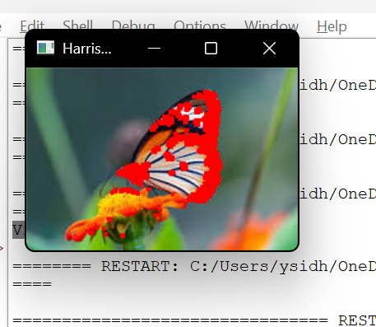
The image with detected corners marked in red.
Result
Thus, Harris Corner Detection was successfully performed on the given image using Python and OpenCV.

